# Assignment 1

**Q1)** Check the output of who, who am I, date, cal and pwd commands.

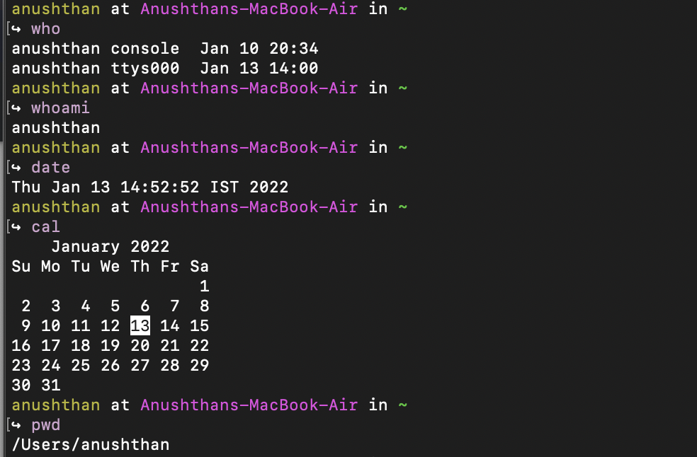

**Q2)**  Write the commands to create the following directory hirarchy:

**-> OCW_Regdno ->OCWass1->dir1**

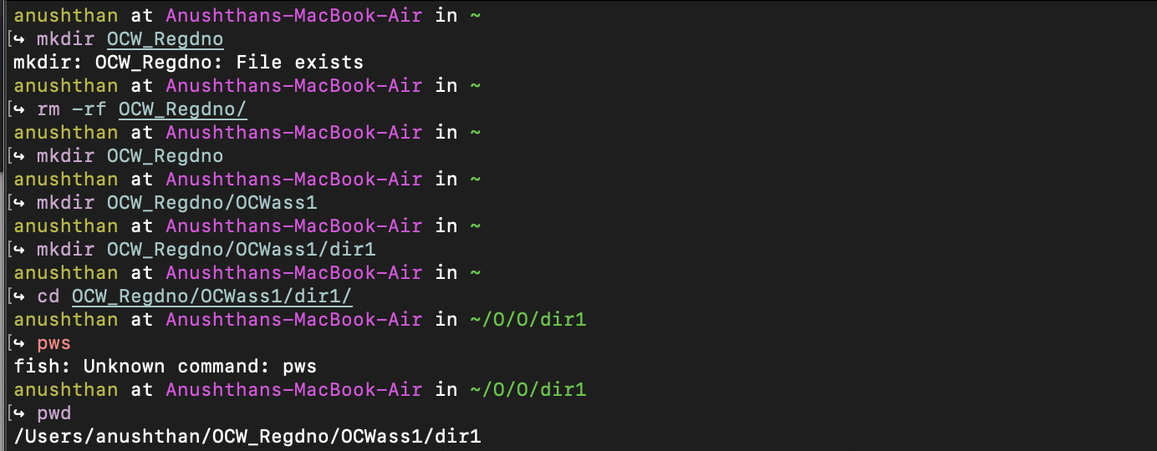

**Q3)** Write the commands to create another directory with name dir2 in directory OCWass1 and make dir2 as the current working directory.

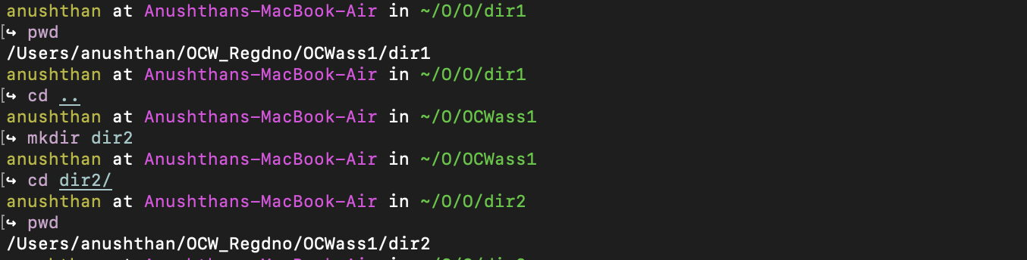

**Q4)** Write the command to delete the directory dir2, when OCW_Regdno will be the current working directory.



**Q5)** Write the command to create a file named as file1 using cat command inside dir1. Write your name, regdno, branch, semester and section in file1. Then display the content of the file.

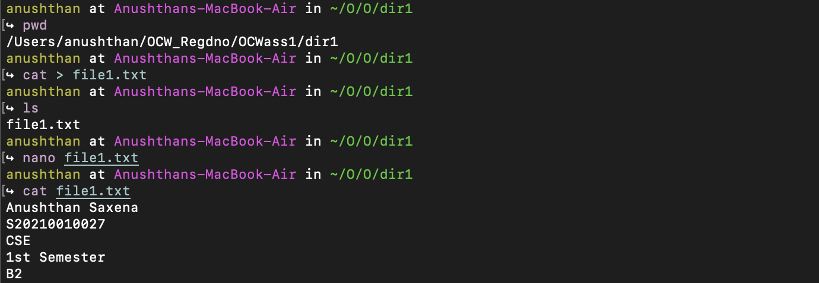

**Q6)** Write the command to create a file named as file2 using cat command inside dir1. Write the subjects you have in this semester in file2.

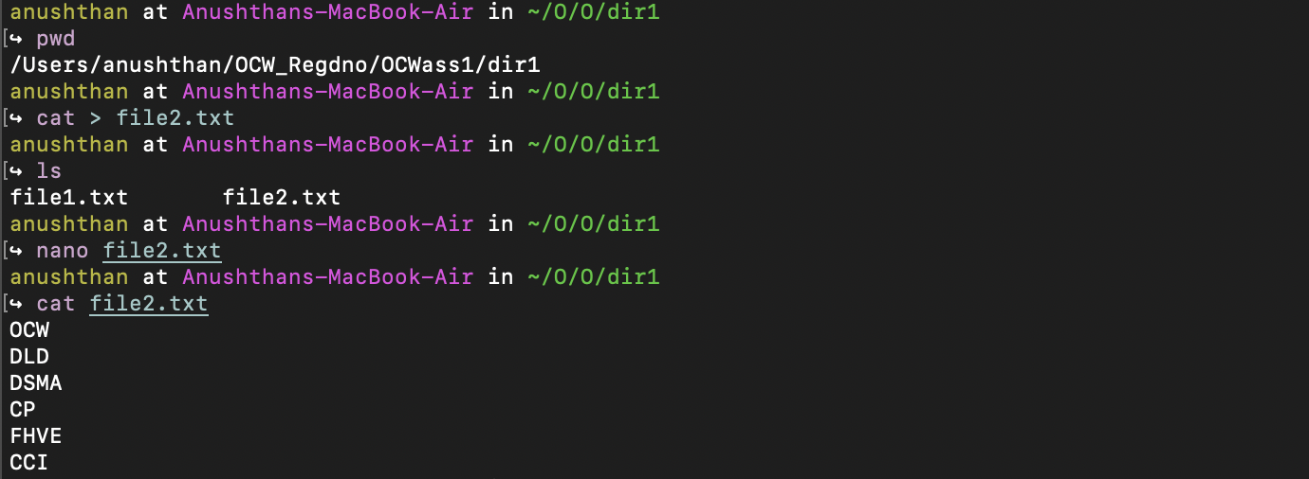

**Q7)** Create a file named as file3 storing content of file1 merged with content of file2.



**Q8)** Write the command to rename file2 as subinfo.

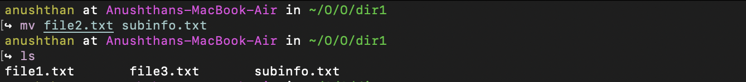

**Q9)** Write the command to copy the content of file1 to reginfo.

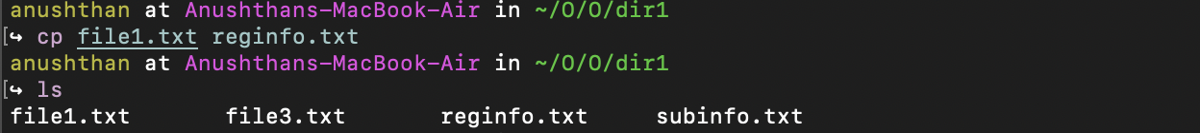

**Q10)** Write the command to delete file1.

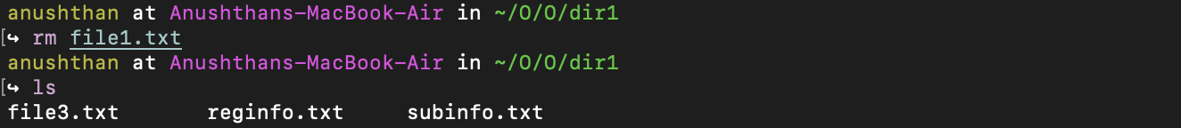

**Q11)** Write the command to create a file named as Personalinfo inside dir1. Write your name, regdno, address in the file.

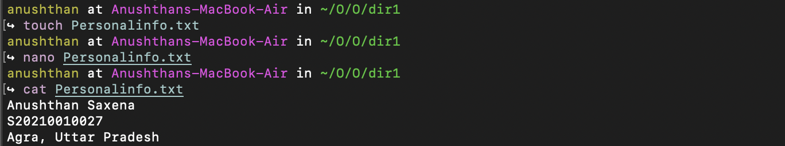

**Q12)** Write the command to display the content of subinfo in reverse order**.**

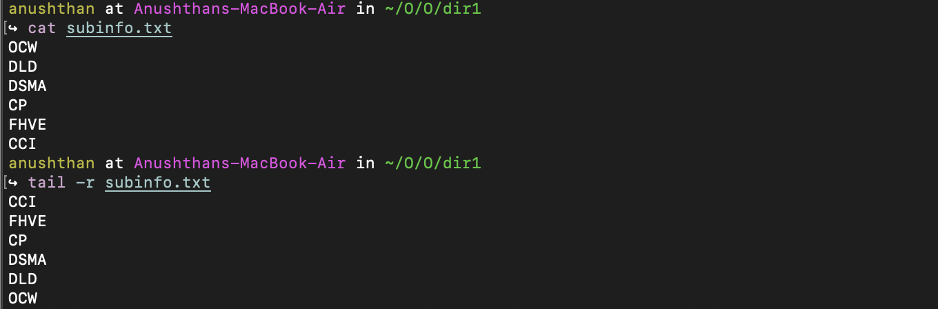

**Q13)** . Interpret the output of the following commands:

echo *

echo ***

echo '***'

echo \***

echo \*\*\*

echo */*

echo Don't do this

echo “Don't do this” (Quotes of one kind protect quotes of other kind)

echo Hello # world

echo “ Hello # world”

echo ' Hello # world'

echo date

echo 'date'

echo “date”

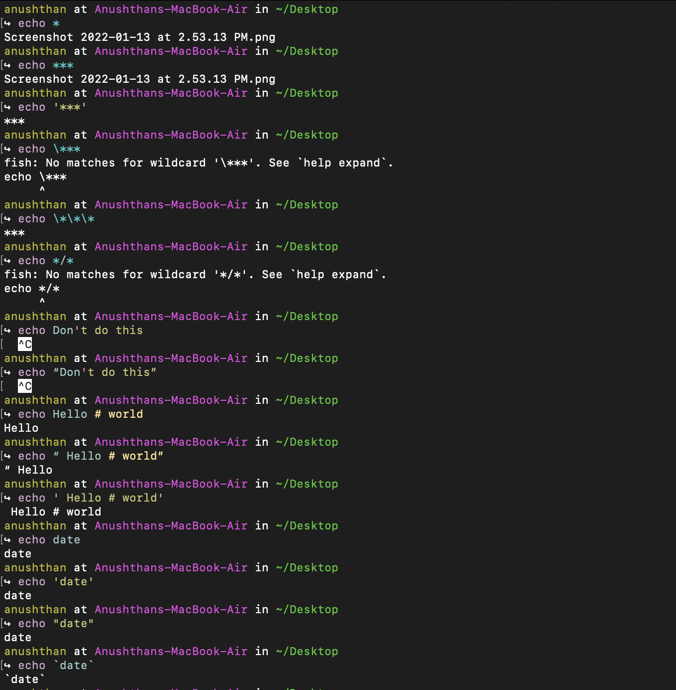echo `date`

bash shell -

